Keycloak Configuration

Step 1.

Login to keycloak and create a new realm (nextcloud) in my case.

Step 2.

Select the realm to start configurations.

Step 3.

Goto: clients -> Create client (enter required information )

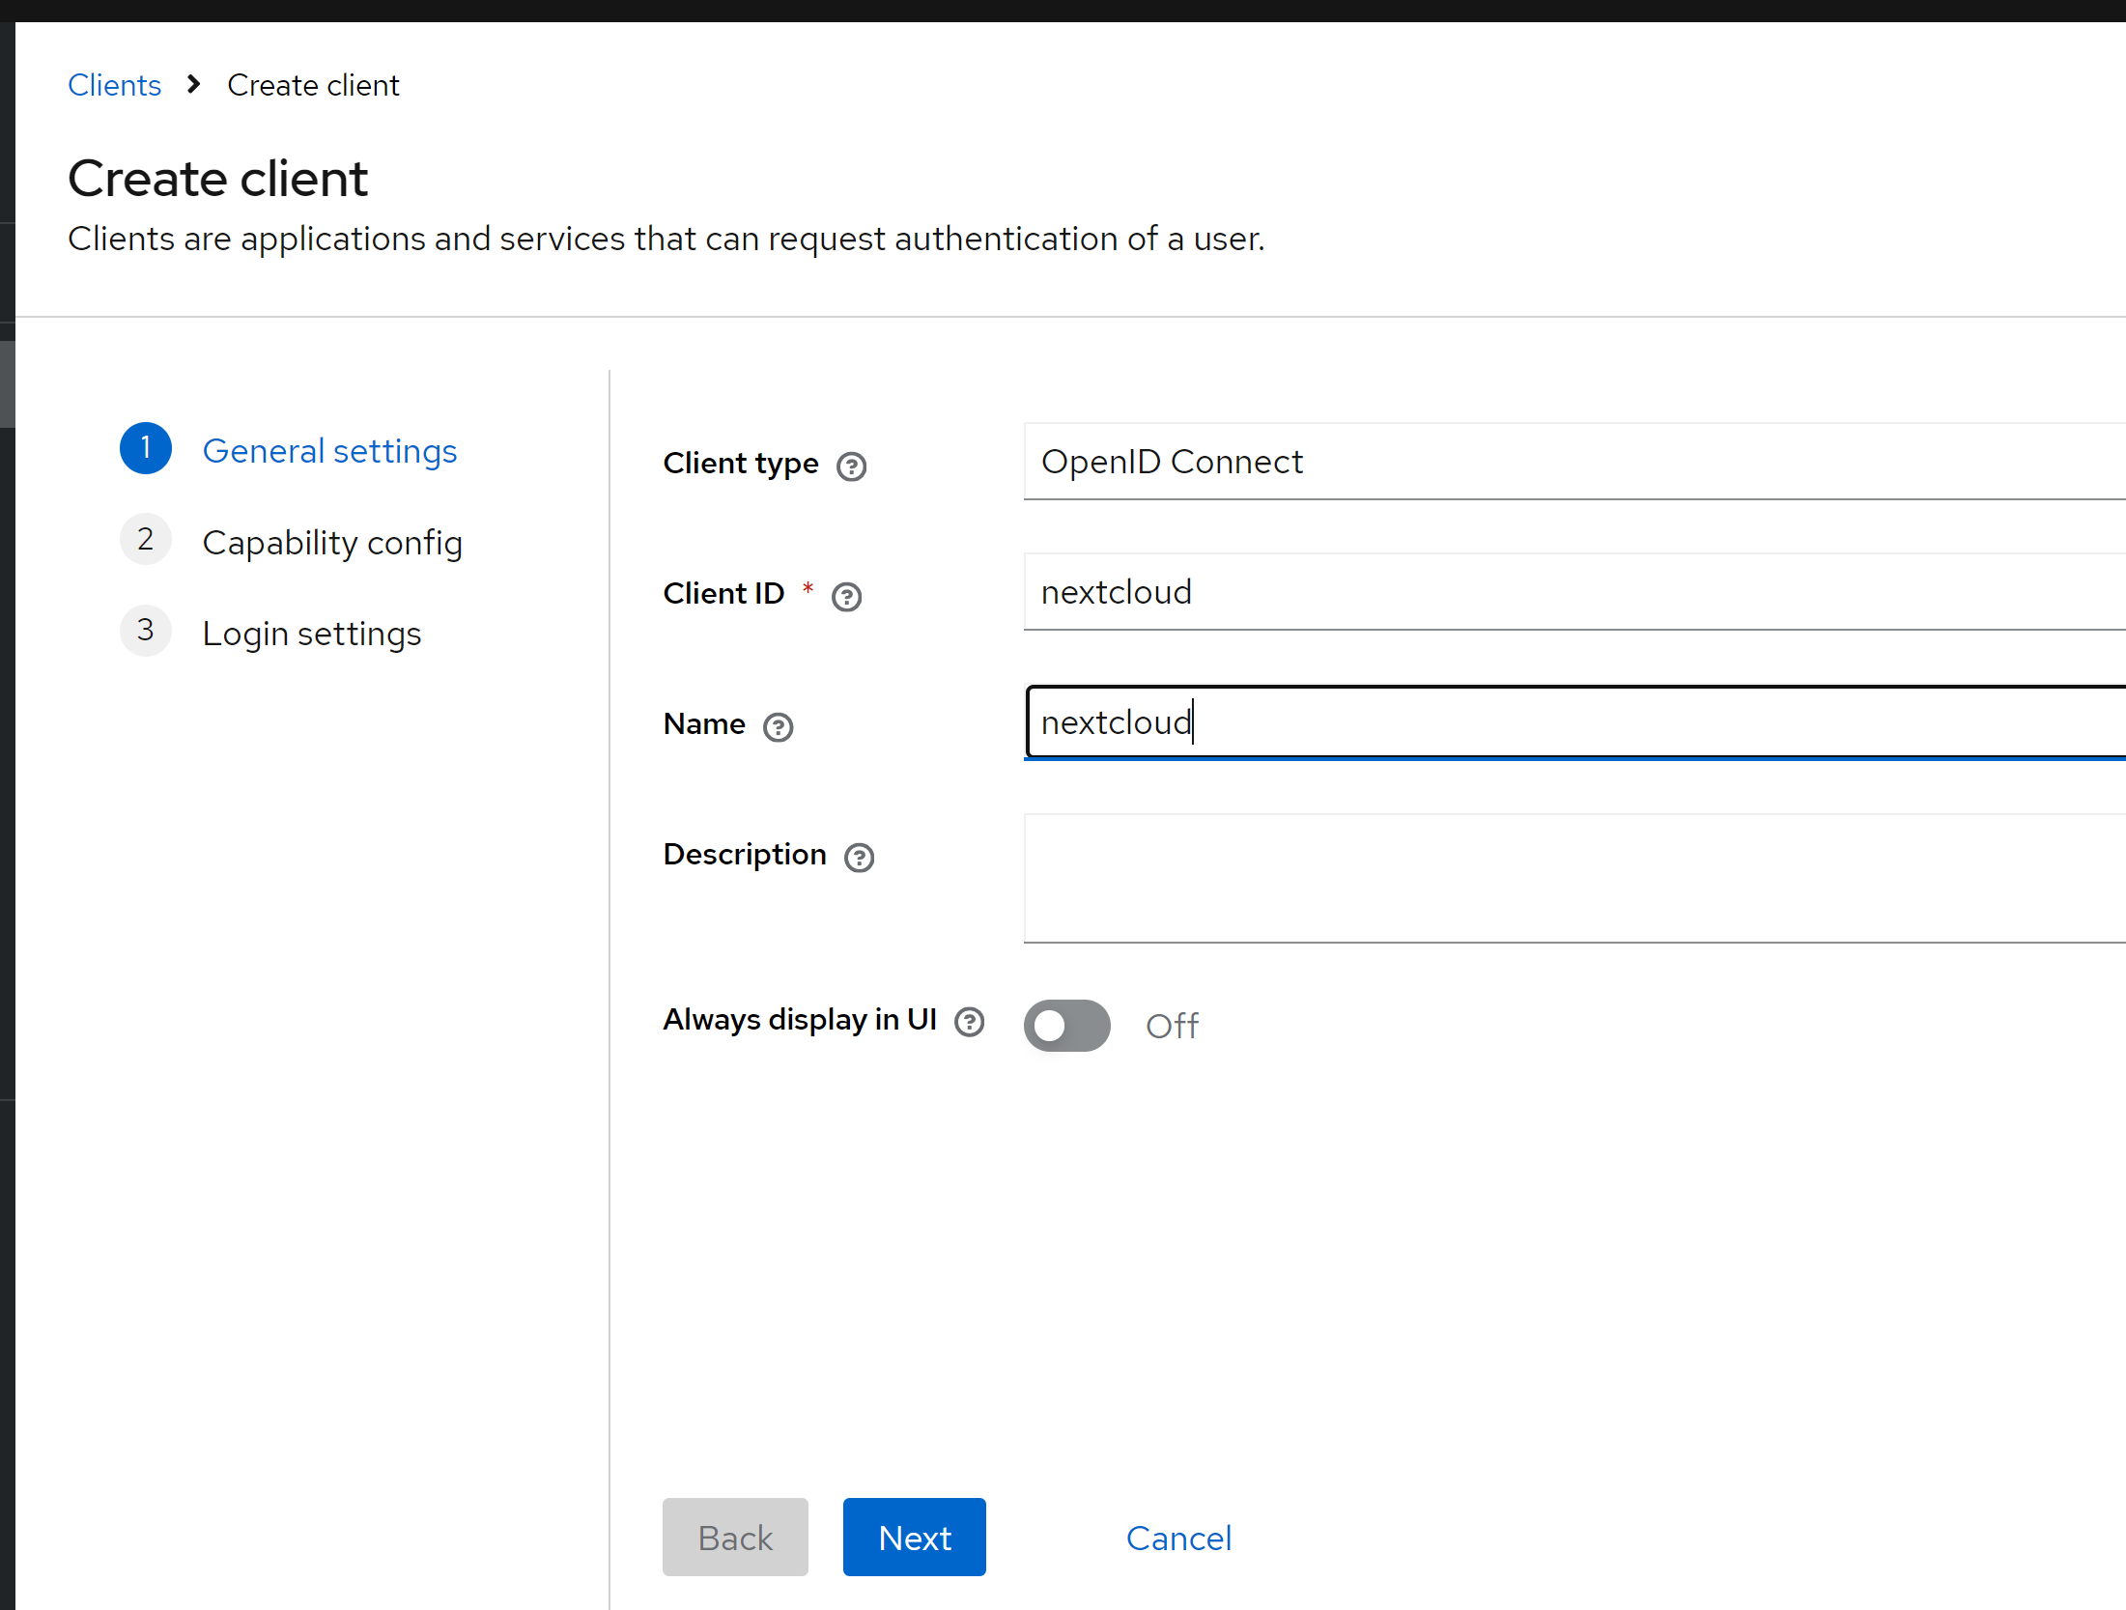

Click Next:

Turn on Client Authentication

Check: Implicit Flow

Click next and enter the URL of nextcloud (in my case nextcloud is deployed in localhost (docker) port 8085 )

One done, save the client.

Step 4:

Select the client we created and click on Roles Tab. Add an admin role. We can change the role as per the application need.

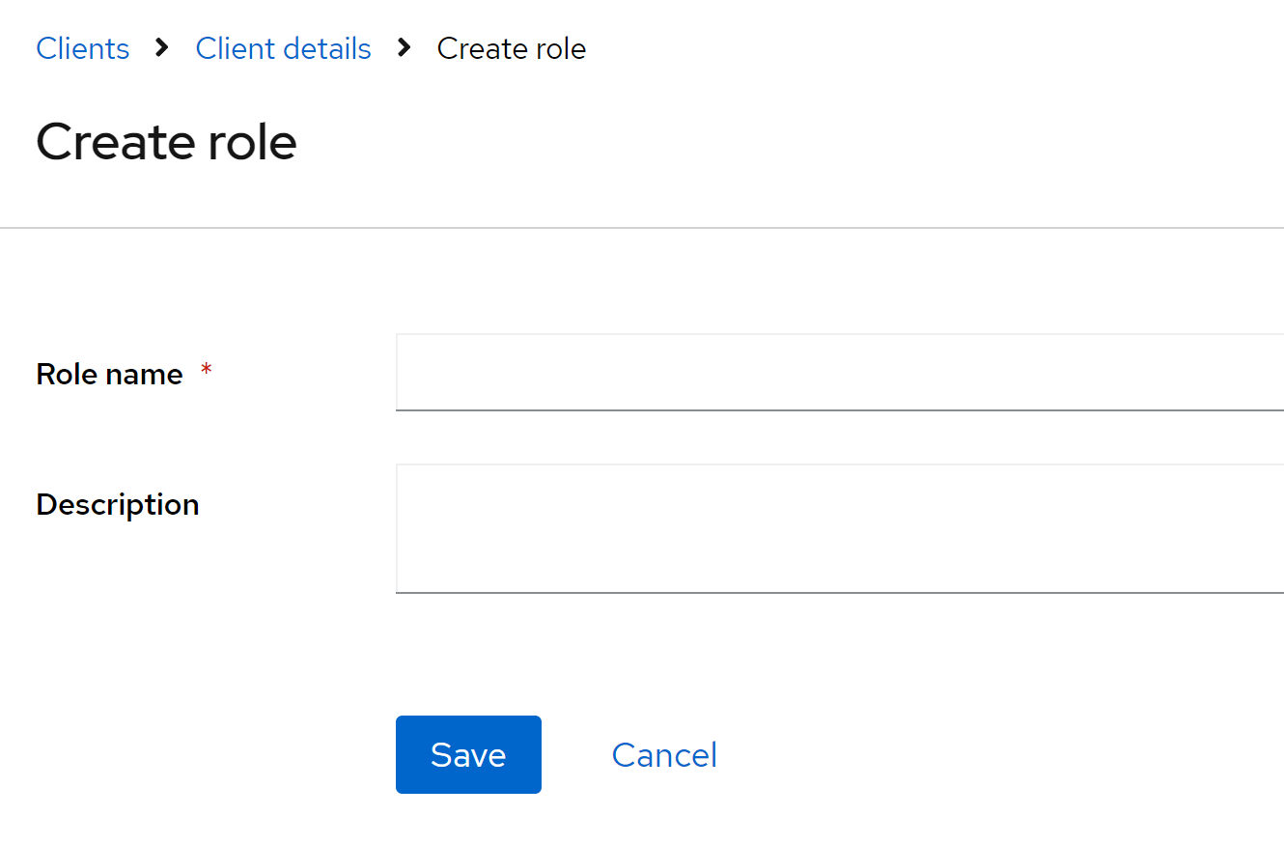

Step 5.

Click on credentials tab and copy Client Secret.

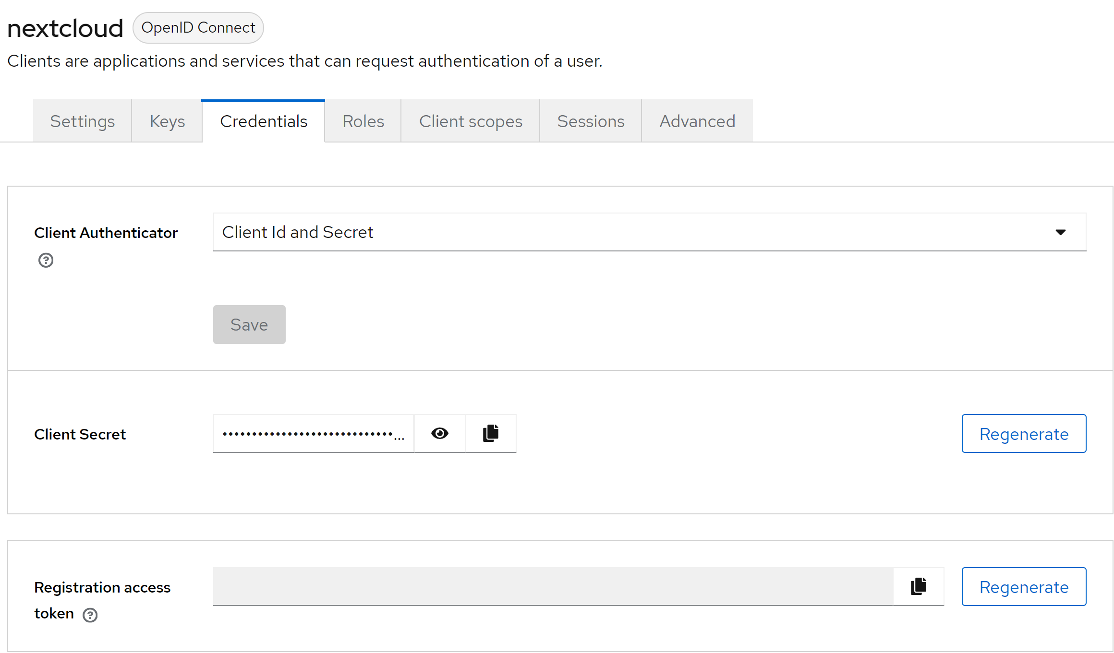

Step 6.

Click on realm settings and then click on “OpenID Endpoint Configuration” link.

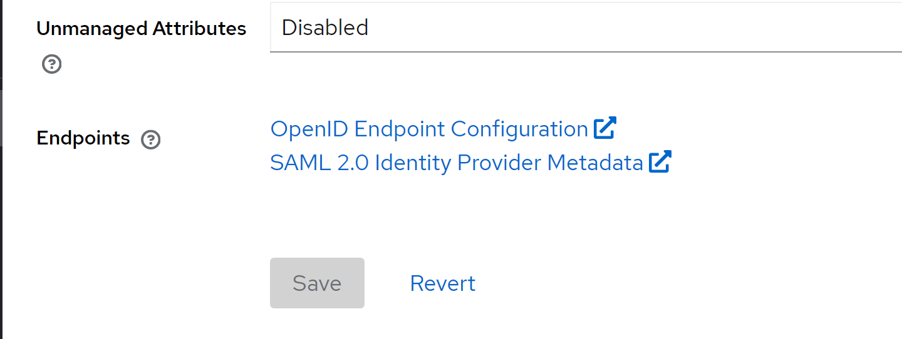

Below page will open up, it will display all the links.

Step 6.

Go to users menu and create a new user along with credentials. In my case I created test user.

NextCloud configuration

1. Login to nextCloud with administrator credentials.
2. Go on apps and enable social login app.

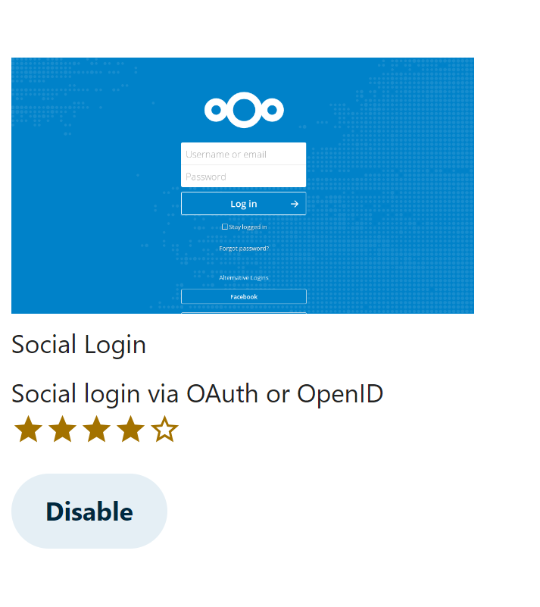

1. Once enabled go to “Administrator Settings” and select “Social login”
2. Fill in all the information retrieved from “OpenID Endpoint Configuration” and Secret Key.

Step 5: we are all set to connect.